Autogenic Drainage exercises
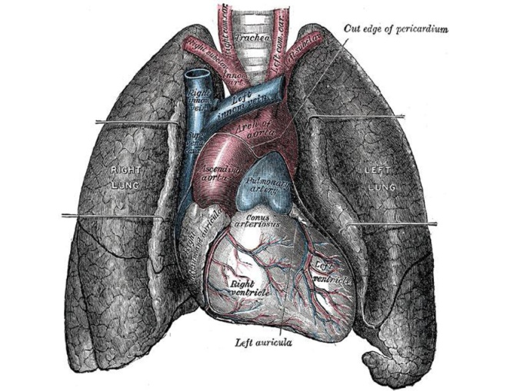

BREATHE!
- Get comfortable in an upright sitting position.
- You may want to slightly lean forward onto a desk, back of chair, or table.
- If extra padding is desired under elbows, use a pillow or folded blanket
- Relax, and practice controlled deep breathing.
- Breathe in thru your nose and out thru the mouth. Your abdomen should move in and out while breathing.
- Your chest should remain rather still, concentrating on watching your stomach rise slightly.
- As you breathe, the mucus is beginning to un-stick- it’ll begin loosening deep in your lungs and work its way up and out.
‘Collect’ the mucus
- If you feel mucus freeing up, this is good. Practice breathing deeper, and you’ll notice the mucus will want to ‘come up and out’.
- Try and hold your cough; continue to breathe deep. If you need to cough, try just a little ‘huff’ cough- but continue to breathe.

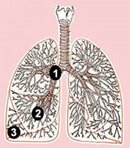
‘Evacuation’ of the mucus
- Now try breathing even deeper into the lungs, bringing in the most air you can. Breathe thru your mouth- you can inhale more air this way vs. nose breathing.
- Continue breathing deeply, (discontinue exercise if you feel faint).
- Try holding your cough as long as possible
- The longer you hold your cough, the more mucus you will collect and bring up & out!

Cough!
- After your largest inhaling breath, tighten your stomach and neck muscles as much as possible.
- Try and maintain your comfortable sitting position.
- Finally, produce two sharp coughs- the second one should be bigger and deeper than the first!
- During the cough, try and keep your abdominals and rib area tight.
Repeat!

Patient directed internet sources
http://hospitals.unm.edu/cf/autogenic_drainage.shtml
http://copdforum.portalone.us/topic.asp?TOPIC_ID=1382

Print Sources
Donahue, Michael. "Spare the cough, spoil the airway:" back to the basics in airway clearance." Pediatric Nursing 28.2 (2002): 107-111. MEDLINE. EBSCO. Web. 8 Feb. 2010.
Waterson, M. "Teaching your patients postural drainage." Nursing 8.3 (1978): 51-53. MEDLINE. EBSCO. Web. 8 Feb. 2010
LCC PTA, February 14, 2010

