Autogenic Drainage Instructions  Autogenic drainage is an airway clearance technique that uses varied airflows to move mucus from different parts of the lungs. The patient must learn to sense when bronchial secretions are present in the airways. Once the secretions become present in the airways, the patient can use effective coughing techniques to get the secretions out of the body. |  | Effective Coughing Instructions  To be effective for airway clearance, either type of cough must generate enough force to clear secretions from the larger airways and move secretions from as far down
Step 1: Relax Phase  Sit upright in a quiet place without distractions.  Start belly breathing by placing your hand on your stomach and noting movement for 2 minutes. Relax. | Step 2: Unsticking Phase  Now exhale and breath normally but minimally filling your lungs to a “low tidal volume”. When you become aware of secretions filling the bottom of your chest, proceed to step 3. | 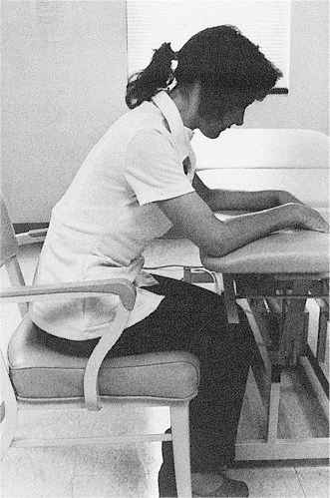 | Step 1: Sit and Lean  Position yourself in a sitting position. Lean forward with the neck flexed, the arms supported, and the feet firmly planted on the floor. Lean against a table, bed or pillow.
Step 3: Collecting Phase  Begin breathing a bit deeper but not the most that you can.. This is called “mid volume” breathing. When you become aware of secretions filling the middle of your chest, proceed to step 4. | Step 4: Evacuation Phase  Breath normally or deeper until coughing cannot be avoided because the secretions really need to be expelled. Proceed to the effective coughing routine on the right side. | 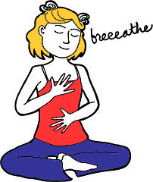 | Step 2: Inhale  Take a deep breath.
People as young as 5 years of age can be taught autogenic drainage with intensive training. Be patient! It takes time to follow this procedure effectively. Autogenic drainage helps to improve ventilation, removing secretions, and enhancing pulmonary function. It is most likely not to lead to low oxygen during treatment compared to traditional postural drainage with percussion. For more information, the following websites may be helpful.  Bronchiectasis R Us explains autogenic drainage in depth: (http://www.bronchiectasis.info/forum/forum_posts.asp?TID=1645)  COP and Coughing Techniques: (http://my.clevelandclinic.org/disorders/Chronic_Obstructive_Pulmonary_Disease_copd/hic_Controlled_Coughing.aspx)  Cameron, Michelle H.. Physical Rehabilitation: Evidence-Based Examination, Evaluation, and Intervention. W.B. Saunders Company, 032007 |  |  | Step 3: Bear Down  Bear down by tightening your upper trunk area.  (don’t do what the picture does but it’s there so you remember to “bear down”!)
 |  | 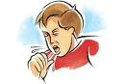 | Step 4: Cough 2 times!  Allowing the pressurized air to expel suddenly. Use a “Huff” sound if the secretions are in your lower chest. Use a “kah” sound if the secretions are higher in your chest.  Have a tissue handy for secretions.

